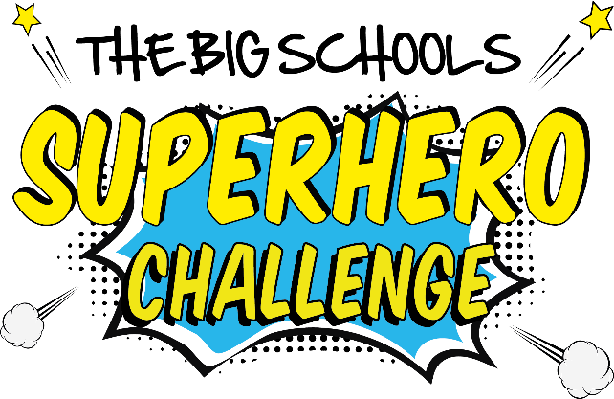

Dear parent

Our school will be taking part in the Big Schools Superhero Challenge, a fun, sporting activity which we hope will raise much needed funds for the Noah’s Ark Children’s Hospital Charity. We’d love your child to join us in   
becoming a school of superheroes for the children of Wales.

The mission of the Noah’s Ark Charity is to support the 73,000 children treated at Wales’ only children’s hospital each year. It funds specialist and life-saving equipment that helps ensure that children are diagnosed and treated quickly and effectively. It also raises money for projects and services to support families like the Noah’s Ark Garden, emergency parent packs and the much loved play specialist team.

On **(insert date)** the children will dress in their favourite superhero costume and   
**(insert run/walk/toddle/wheel)** **(insert 1k or 2k)** in return for sponsorship.

To give permission for your child to take part in this event, please complete the form below and send it back to us. The children will then receive sponsorship forms and a guide to making their own superhero costumes should you wish to do that with them. **(please amend as appropriate if you have decided to make costumes in school as a craft activity or you have set it as a homework task)**

Thank you for playing your part in helping our school support children in both our own and the wider community.

Child’s name:

Name of parent/guardian:

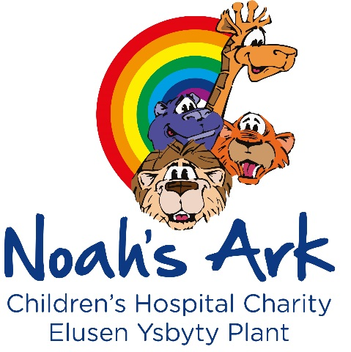 **Yes** I give permission for my child to take part in the Big Schools Superhero Challenge

**Yes** I would like to come along on the day to support.

Date:

Registered charity number: 1069485