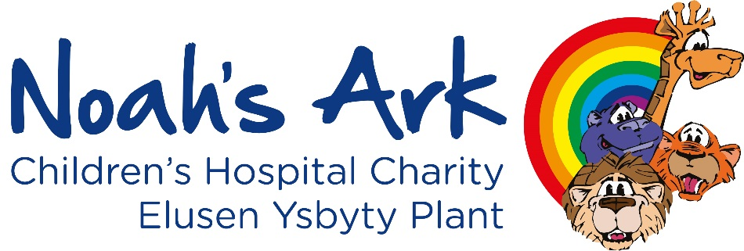

**Job title:** Digital Marketing Officer

**Reports to:** Head of Communications and Engagement

**Location:** Hybrid with a minimum of two days per week in the charity office at theNoah’s Ark Children’s Hospital for Wales

**Contract**: Permanent

**Hours:** 30 hours

**Salary:** £33,000 FTE (Pro ratad)

**About the Noah’s Ark Charity**

Children and families are at the heart of everything we do at the Noah’s Ark Children's Hospital Charity.

Working alongside our incredible community of supporters, we ensure that treatment and outcomes for children can continue to improve by funding new and innovative medical equipment and facilities. We support children and families in the here and now through our emotional support services and the much loved play specialist team and we invest in the future by providing technology that helps train the bright clinicians of tomorrow. We also strive to make the hospital a less frightening and more familiar place for children by sprinkling a little fun and happiness into hospital days.

As a charity that relies entirely on donations and gifts in Wills – this is all made possible thanks to the public’s generosity.

**Scope of role**

The digital marketing officer is a new role within the communications and engagement team, reflecting the charity’s strategic ambitions to shape and improve our digital approach.

We are a friendly, creative, and supportive team, responsible for raising awareness, demonstrating impact, growing the brand and supporting both our fundraising colleagues and our committed community of fundraisers, donors and volunteers to raise as possible in aid of our nations children’s hospital.

As digital marketing officer you will play a key role in developing and implementing our digital strategy, working closely with the fundraising and wider communications and engagement team to deliver tangible results. It is also an exciting time to join our team, as this role will begin at a critical point in the redevelopment of our website. The digital marketing officer will play a vital part in the ongoing rollout of the site.

Working closely with the wider charity team, this new position offers a real opportunity to help develop and grow the charity’s positive impact on the lives of children and families.

**Key duties and responsibilities**

* Work with the head of communications and engagement to develop and implement a comprehensive digital marketing strategy aimed at growing audiences and boosting engagement across digital platforms.
* Lead and support the planning, execution, and optimisation of multi-channel marketing campaigns (including digital fundraising, email and social media) in order to acquire, retain, and upgrade supporters, maximise attendance at our events and increase participation in our fundraising activities and products.
* Manage paid digital advertising campaigns (e.g. Google Ads, Meta Ads), including the development and optimisation of Google Ads Grants in line with marketing objectives.
* Develop, maintain and enhance the organisation's website, ensuring content is current, accurate, and aligned with SEO and UX best practices.
* Create a range of content using Canva Pro, including but not limited to content for the website and social media channels in addition to providing design support to other areas of the business
* Build and optimise digital content across platforms, using tools such as GA4 and Meta insights to inform performance and improvements.
* Develop and deliver tailored digital supporter journeys, using the organisation’s CRM, collaborating with the fundraising team and data officer to define audience segmentation and campaign targeting.
* Champion digital best practice across the organisation, ensuring all content meets SEO, accessibility, GDPR, and Fundraising Regulator guidelines.
* Work closely with the communications and engagement team to ensure digital content aligns with broader communications strategies and maintains consistent branding and messaging.
* Provide regular reports on campaign performance, website analytics, and KPIs across platforms, using insights to refine strategy and improve future content and engagement outcomes.
* Track and report on digital marketing expenditure and campaign ROI, ensuring transparency and effectiveness of digital spend.

Other responsibilities

* Contribute to the operational and strategic development of the charity. Also to undertake other duties which may from time to time be requested by heads of department.
* Contribute to the strengthening and consolidating of existing organisational processes.

**Person specification: Digital Marketing Officer**

|  |  |  |  |
| --- | --- | --- | --- |
| **Criteria** | **Essential** | **Desirable** | **How/when tested** |
| **Qualifications and training** |  | Qualifications or training in digital publishing, digital marketing, Google Analytics, SEO, UX, copywriting, and any related software or technology.  Educated to degree level. | Application form and pre-employment checks |
| **Experience** | Extensive experience in a digital marketing role, including SEO, paid search and display advertising, paid social media and email marketing.  Proven track record in developing and implementing successful digital marketing strategies.  Experience in writing for digital channels and creating content tailored to a variety of audiences.  Practical knowledge of website management, using content management systems, on-page and technical SEO and digital best practice.    Experience using email platforms as part of the marketing mix.  Good knowledge and experience of using analytics tools such as Google Analytics and Meta Insights for reporting, tracking performance and identifying actionable insights.  Proven ability to work to brand guidelines, producing aesthetically pleasing collateral and marketing materials using tools such as Canva.  Proven track record in allocating and managing budgets on paid channels, including Google and Meta Ads.  Designing and monitoring all paid advertising, including but not limited to Meta and Google Ads.  Up-to-date knowledge of latest developments in the digital marketing industry.  Experience in ensuring content is optimised for search engine results. | Experience (or interest in) working within the charity sector and an understanding of the principles of the donor pipeline and donor/supporter engagement.  Experience of digital collaboration and project management tools like Monday and MS teams.  Experience of helping to shape stories and communicate social impact to raise profile and income.  Experience of working with contractors, agencies and freelancers.  Experience using CRM or supporter databases  Knowledge of UX. | Application form, interview and  references |
| **Skills/Competencies** | Excellent copywriting, editorial and proofreading skills with the ability to adapt tone for different audiences.  Strong communication and relationship-building skills.  Adaptability to work in a fast-paced environment.  Excellent problem-solving skills, with the ability to develop creative solutions to potential roadblocks  Ability to communicate, work collaboratively and build good working relationships.  Attention to detail, ensuring high-quality and consistent content.  A self-starter who can work independently and as part of a team.  Strong organisational skills with the ability to work proactively and manage multiple projects concurrently.  Strong administrative and project management skills, with experience managing multiple projects while effectively meeting deadlines.  Ability to prepare and deliver reports and presentations.  Target driven and proactive in achieving results. |  | Application and interview |
| **Personal attributes** | A passion for helping children and families.  An excellent team member.  Adaptability and flexibility.  A sense of humour and positive outlook.  Ability to work independently, as well as collaboratively as part of a small team.  Energetic, enthusiastic, committed, adaptable and motivated.  Positive in outlook: always looking for the best outcomes from dealing with people and situations.  Self-aware: know gaps in your own knowledge and skills, and not be afraid to ask for assistance. |  | Application and interview |
| **Other** | Ability to travel within Wales / UK geographical area if required.  Able to work hours flexibly when required.  Be professionally presented.  Complete confidentiality and discretion in handling sensitive data. | Welsh speaker. | Application form and interview |

**Date updated : 15/04/25**

**Prepared by: Bethan Simmonds, Acting Co-Director and Head of Communications and Engagement**

**Agreed by Lucy Jones, Acting Co-Director and Head of Fundraising and Development.**