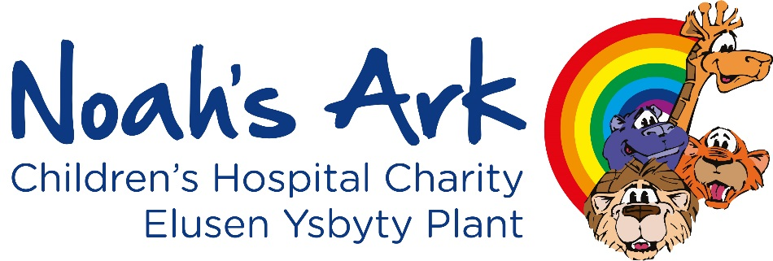

Job title: Marketing Manager
Reports to: Co-Director
Location: Hybrid with a minimum of three days per week in the charity office at the Noah’s Ark Children’s Hospital for Wales
Contract: Permanent
Hours: 37.5 hours
Salary: £40,000

About the Noah’s Ark Charity
Children and families are at the heart of everything we do at the Noah’s Ark Children's Hospital Charity. Working alongside our incredible community of supporters, we ensure that treatment and outcomes for children can continue to improve by funding new and innovative medical equipment and facilities. We work in partnership with the health board to create environments with the needs of families at their core and support the wellbeing of children and young people through counselling, specialist play and music therapy. We also strive to make the hospital a less frightening and more familiar place for children by sprinkling a little fun and happiness into hospital days.

As a charity that relies entirely on donations and gifts in Wills – this is all made possible thanks to the public’s generosity.

Scope of role
We’re looking for a dynamic and results-driven marketing manager to join the Noah’s Ark Children’s Charity team. This new position will provide the successful candidate with the opportunity to play a key role in shaping our marketing strategy, elevate brand presence, and drive growth.
Both varied and rewarding, the position combines strategic thinking with hands-on delivery. You will lead and deliver marketing campaigns to strengthen our reputation and grow our impact, increasing both awareness and fundraising and consolidating our position as one of Wales’ leading charities. The postholder will form part of a wider cross functional management team, working closely with both fundraising and service delivery colleagues.
If you are an experienced communications professional with a passion for making a difference and a proven track record in delivering successful campaigns and inspiring teams, we’d love to hear from you!

Key duties and responsibilities
- Work closely with the Co-Director to create and develop a communication and engagement strategy to run alongside our new organisational strategy.

Lead marketing delivery and growth by planning and delivering integrated brand and fundraising campaigns across digital, content, social, email and offline channels.

Develop, update and maintain a suite of printed marketing materials following the imminent rollout of the charity’s refreshed brand and launch of our new five year strategy.
- Manage a small team to collectively deliver and optimise marketing activity, providing direction, guidance and overseeing appraisals and objective setting.

Build and maintain media partnerships, securing sponsorship and promotional opportunities to raise brand awareness and generate income.

Monitor brand and messaging delivery, ensuring messaging is warm, clear, consistent and people-centred.

Supporting colleagues through effective internal communications to use the new brand and our tone of voice confidently and consistently.

Drive insight and continuous improvement, using data, feedback and performance analysis to shape marketing plans, share learning, and take a test-and-learn approach to improving reach, relevance and impact.
- Ensure effective monitoring and analysis is conducted and organisational monitoring and evaluation targets are met.

Build strong, collaborative working relationships, managing agencies or freelancers where needed, and ensuring all marketing activity reflects brand standards, safeguarding, GDPR and equality commitments.

Develop and deliver tailored digital supporter journeys, using the organisation’s CRM, collaborating with the fundraising team and data officer to define audience segmentation and campaign targeting.

Research and understand our target audiences to increase profile with key audiences.

Develop and deliver a celebrity and influencer engagement strategy to support the awareness, engagement, and fundraising objectives of the organisation.

Generate creative, engaging content and ideas for fundraising, events and brand awareness campaigns that drive increased targeted engagement to showcase our work and deliver our fundraising ambition.

Proactively develop relationships in the sector and maintain awareness of sector developments and campaign to drive forward an innovative team culture.

Special conditions
- Some out-of-office and out-of-hours work and travel will be required from time to time in order that the organisation is able to deliver on its commitments.
- All staff must adhere to the charity’s safeguarding policies and procedures
- All staff have a responsibility to maintain an up-to-date knowledge and awareness of issues around the safeguarding of children, through the completion of the relevant training, at a level commensurate with their role
- Ensure compliance with charity policies and all relevant legislation
- Demonstrate behaviours in line with the charity values and maintain the reputation and standing of the charity
- The list of responsibilities outlined above are not intended to be exhaustive and the post holder may be required to carry out other reasonable tasks or responsibilities under the direction of the Fundraising and Engagement Director

Person specification
 | Essential | Desirable
Qualifications |  | Educated to degree level.  Qualifications or training in marketing, people management, digital publishing, Google Analytics, SEO, UX, copywriting, and any related software or technology.
Experience | Proven success in developing and delivering marketing strategy and campaigns across both digital and print channels.  Experience of working with senior stakeholders to translate organisational or strategic objectives into a marketing plan.  Experience managing or supervising others.  Track record of managing budgets and supplier relationships (eg print production, agencies, freelancers).  Experience of using data and insight for the purpose of reporting and to inform and improve marketing and communication activities - using tools such as Google Analytics and Meta Insights.  Proven ability to work to brand guidelines to produce collateral and marketing materials using tools such as Canva.  Experience of website management using content management systems.  Experience building and managing partnerships to support organisational objectives, with the ability to identify, approach and maintain relationships with external stakeholders. | Experience working within the charity sector and an understanding of the principles of the donor pipeline and donor/supporter engagement.  Experience securing media coverage, sponsorship or promotional opportunities, including negotiating in-kind or paid partnership agreements with media outlets or corporate partners.  Experience in the use of project management and business intelligence tools such as Airtable and Power BI.  Experience of helping to shape stories and communicate social impact to raise profile and income.  Basic knowledge of CRM or supporter databases.
Skills and competencies | Strong understanding of the full marketing mix - digital (web, email, social, paid/organic) and offline/print production.  Working knowledge of SEO, paid search and display advertising, paid social media and email marketing.  Knowledge of principles of relationship management and good customer care.  Confident and clear written and visual communicator, with the ability to maintain brand and tone consistency across formats.  Working knowledge of using data/insight/analytics to shape and evaluate campaign performance.  Confident and enthusiastic presenter and networker.  Ability to lead and motivate a small team - setting direction, delegating effectively, reviewing work and developing people.  Ability to manage multiple concurrent projects/campaigns to deadline and budget, prioritising effectively.  Adaptability to work in a fast-paced environment.  Excellent problem-solving skills, with the ability to develop creative solutions to potential roadblocks.  Excellent copywriting, editing and proof-reading skills with an attention to detail that ensures high-quality and consistent content. | Welsh speaker.  Competency in Fundraising Code of Conduct guidelines.
Disposition | Influencer – who stimulates others into action.  Multi-tasker with a sense of urgency for goal achievement.  Effective delegator with accountable follow-up on timeliness and quality.  Ability to learn quickly and thoroughly and adapt to change.  Self-aware: Acknowledging gaps in personal knowledge and skills, and not afraid to ask for assistance.  A passion for making life better for the children, young people and families we support.
Thinking Style | Innovative and creative idea generator.  Timely decision maker, in response to varied activities and changing conditions.  Enthusiastic and collaborative.  Practical and results focused.  Big picture thinker.

How to Apply

- Deadline for applications: Midnight Monday 7 September.
- Interviews will take place: w/c 21 September

Note: This job description is intended to outline the general nature and level of work performed by employees within this role. It is not exhaustive and may be subject to change or modification as required by the needs of the charity. The Noah’s Ark Children’s Hospital Charity is committed to equal opportunities and positively welcomes applications from all sections of the community. The charity is committed to safeguarding children and vulnerable adults. The post holder will be required to complete an enhanced DBS disclosure check.

